**Mobile Application Development (3701ICT/7421ICT)**

Trimester 1, 2024

Assignment 2

**Fake Store**

Final Submission

Student Name: Pouya Yazdani

Student ID: s5284016

Student Email: Pouya.yazdani@griffithuni.edu.au

Course Code: 3701ICT

Lab: Tuesday 4-6 pm

Lab Tutor: Abdul Fofanah

Table of Contents

Project Overview (Optional) 3

GitHub Repository 3

Video Link 3

Project Reflection (Master students only, no more than one page) 3

## Project Overview (Optional)

I made all the changes we needed for the final submission and completed the fake store.

## GitHub Repository

<https://github.com/zero2003/Fake-Store.git>

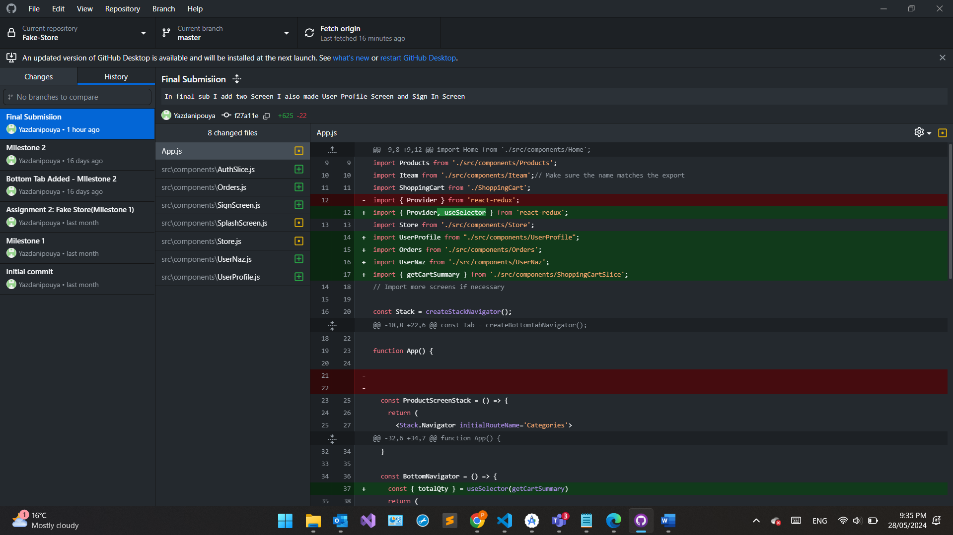

## Video Link

<https://youtu.be/Vl9Iag60SxU>   
Thanks for your time  
 my Extension prof:  
